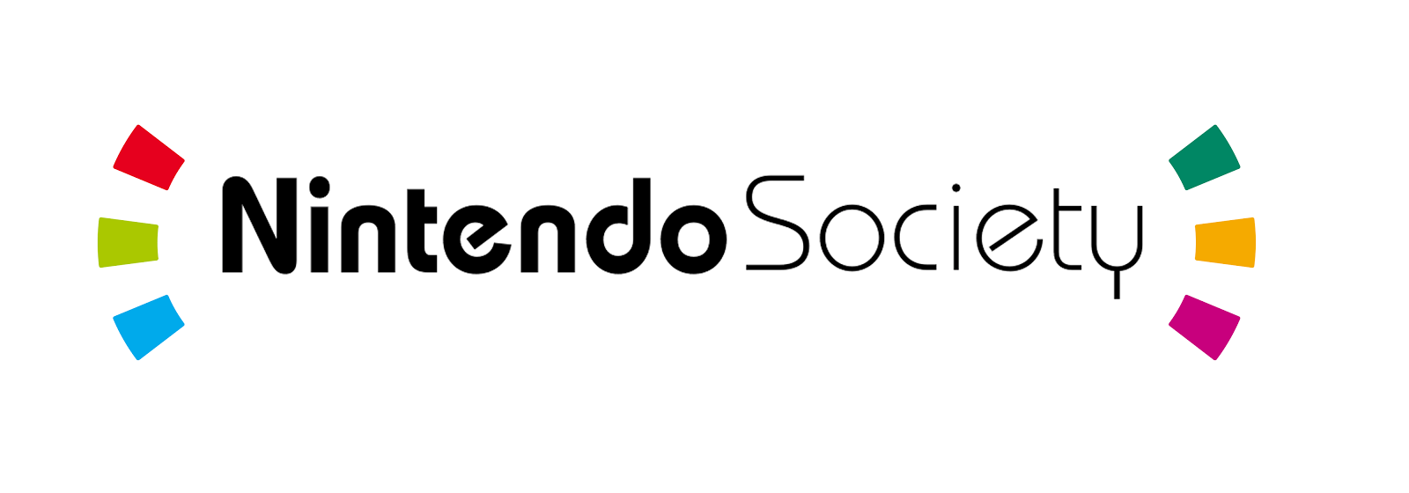

We are honoured to present a new exciting society for all Nintendo loving fans at the University of Warwick. We provide Nintendo themed gaming and social events in the hope that it will make your time at university a more enjoyable and memorable experience.

Currently we hold events on Monday and Wednesday each week. Our Monday events consist of a library of playable Wii and Wii U games allowing for friendly local multiplayer fun. Members with 3DS consoles can also receive Streetpass hits and enjoy handheld multiplayer games. On occasion, Pokémon anime and movies are shown for members to enjoy and relax after a long start to the week.

Wednesday events are focused on the Super Smash Bros. series of games including Wii U, Melee and on occasion PM, Brawl and 64. We provide an array of setups and these sessions are open to members of all skill levels, from those who have never played to those who play and follow the competitive scene. We offer coaching sessions for those interested in improving, and we hold tournaments each week so members can test their skill with the society’s best players.

Considering the near future, 2017 is looking to be a great year for Nintendo and we hope to bring a lot of these new ideas into the society. Miitomo and Pokémon Go have been successful and were some of the first smartphone apps for people to enjoy Nintendo games on the go. With more Nintendo games being released for mobile devices including Fire Emblem Heroes and Super Mario Run, it has become even easier to engage with the Nintendo community and experience the gameplay with most apps being free to play.

From March 2017, Nintendo Society will share the joy to its members with the new Nintendo Switch console being available to play. Nintendo Switch has 3 different play styles namely TV mode, Tabletop mode and Handheld mode, all of which can be utilised at our events. Members will be able to experience this next generation console for the very first time shortly after release, and more titles for the Switch will be released and playable at our events in the coming months. Providing this platform to try out the Switch can potentially convince members to purchase one themselves in the future, further sharing the joy to their friends and growing the community.

Also, we want to build a platform for people to be involved in the competitive Super Smash Bros. scene across the UK. Along with our local training and tournament sessions, we go to cities such as Birmingham to participate in larger tournaments. These have been successful and enjoyable trips for both entrants and spectators in the past, and we hope to continue this in future years. A future objective would be to create an inter-university esports scene or competition such as Varsity by collaborating with other gaming societies at Warwick and at other universities.

The original idea for making this society was formulated two years ago. Watching a small group of friends grow into a smaller community was great, and in 2017 we have the opportunity of making this society into something special. For only £3, you’ll join a friendly community and make new friends who share similar interests to you. You’ll get to experience the joy of the Nintendo universe at our events without having to own one of their consoles, and you can even play with friends on the go with the various smartphone apps available.

Well then, folks, until next time, stay fresh! And we hope to see you at one of our events soon.